**Coursedog – Getting Started**

**Logging In**

* Go to <https://app.coursedog.com/#/products>
  + Enter your [unid@utah.edu](mailto:unid@utah.edu) email address
  + Not your alias address!
* Enter your Duo SSO Credentials
* You will not need to set up a password for Coursedog.

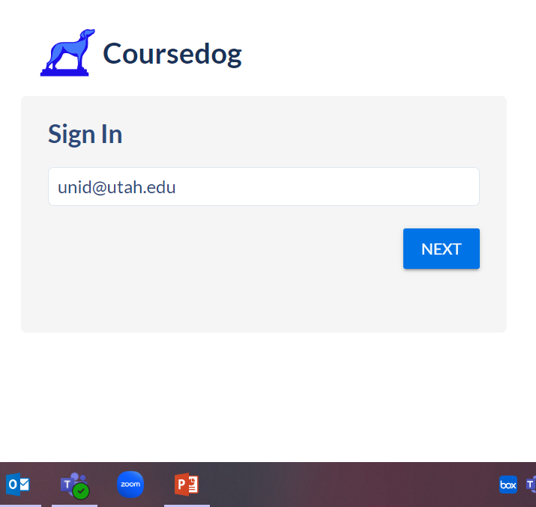

**Coursedog Dashboard**

* If you have access to more than one product from Coursedog, you will see the page below. To proceed, click ‘Curriculum.’

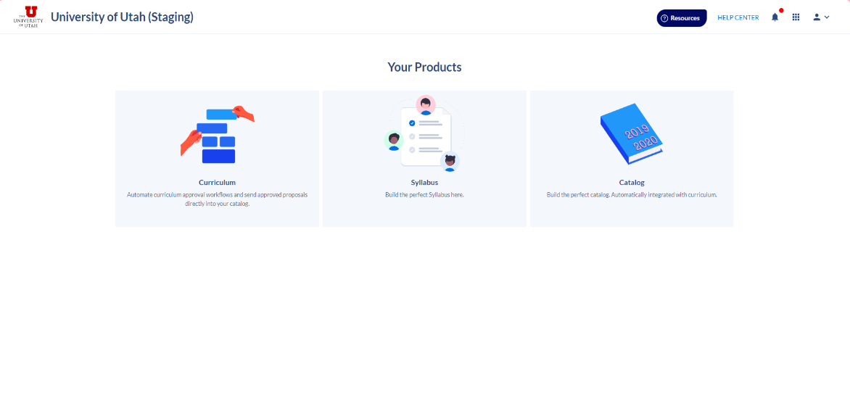

* Once logged in, you will see a dashboard that lists any tasks that require your attention.

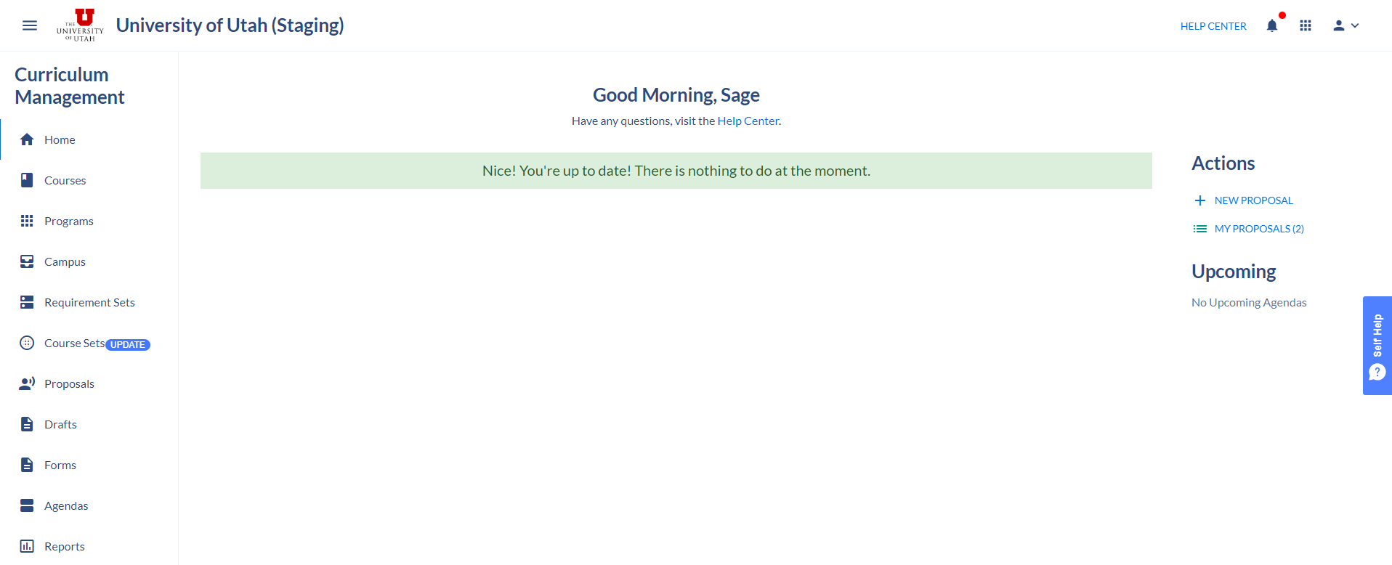

**Account Settings**

* To adjust your account settings, click the ‘person’ icon in the top right corner of the page and select ‘Account Settings.’
* At the bottom of the Account Settings page, you can adjust your email notification preferences.
* Below are examples of both ‘Daily Digest’ notifications and ‘Immediate.’

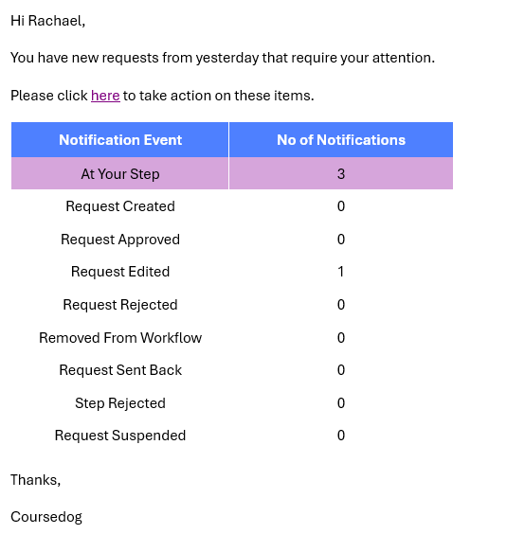

User

User

**Actions**

* Always start here!

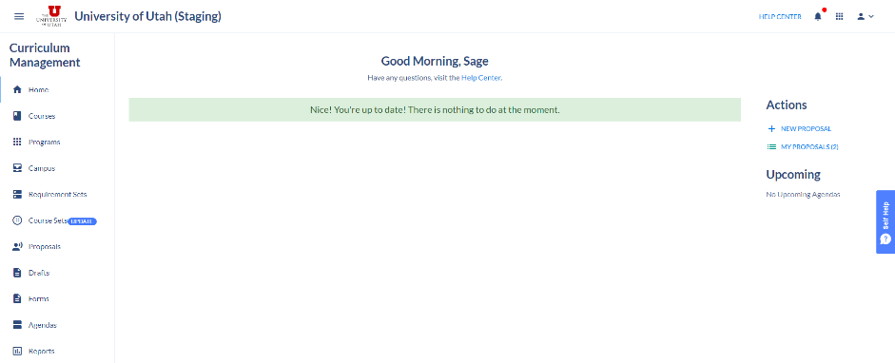

* Below is a list of all of the actions you can take:
  + Create a New Course
  + Create a New Program
  + Modify a Course
  + Modify a Program
  + Inactivate a Course
  + Reactivate a Course
  + Add or Adjust a Fee on Existing Course
  + Suspend or Discontinue a Program
  + Add Emphasis to Existing Degree
  + Academic Unit Changes
  + Change Program Contact Information or Description
  + Update Curriculum Approvers/Contacts
  + Add 100% or Uonline Program
  + Combine a Bachelor and Master Degree
  + Propose Dual Degree (Graduate Level Only)
  + Cross-listed Course Change