**Coursedog – Approving a Proposal**

**Finding Proposals**

Once a proposal has been submitted that you are an approver for, you will receive an email like the one below. Click the link in the email to be taken directly to the proposal in Coursedog.

**Course or Program Name**

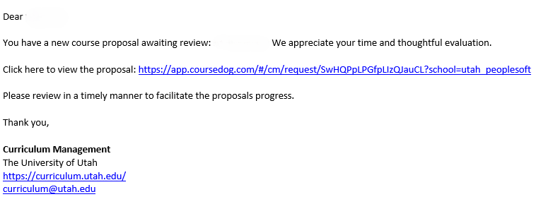

To view all of your active tasks, visit the Dashboard on the Curriculum Management home page (see below). Click on any of the course/program requests on your Dashboard to be taken to the proposal.

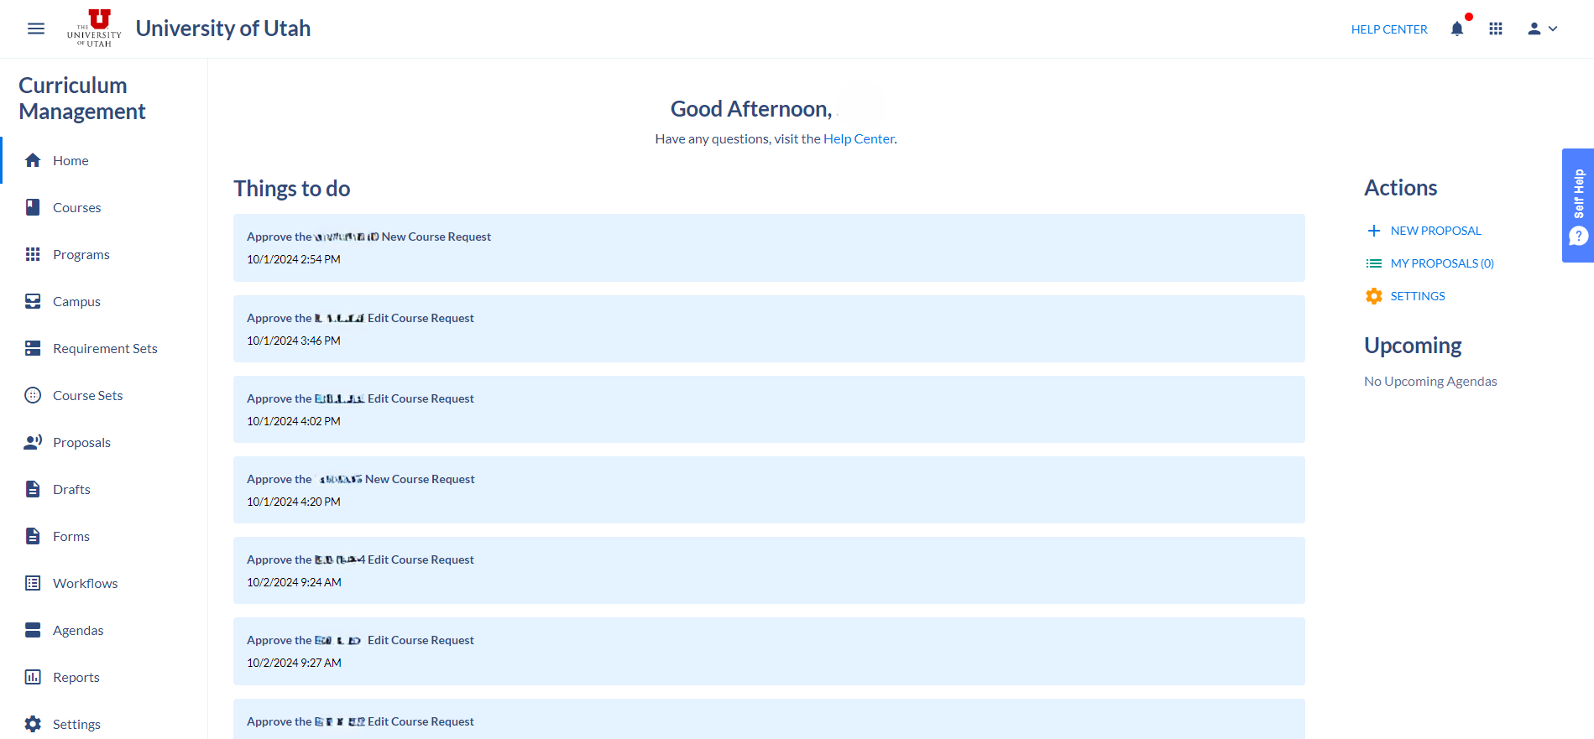

**Making a Decision**

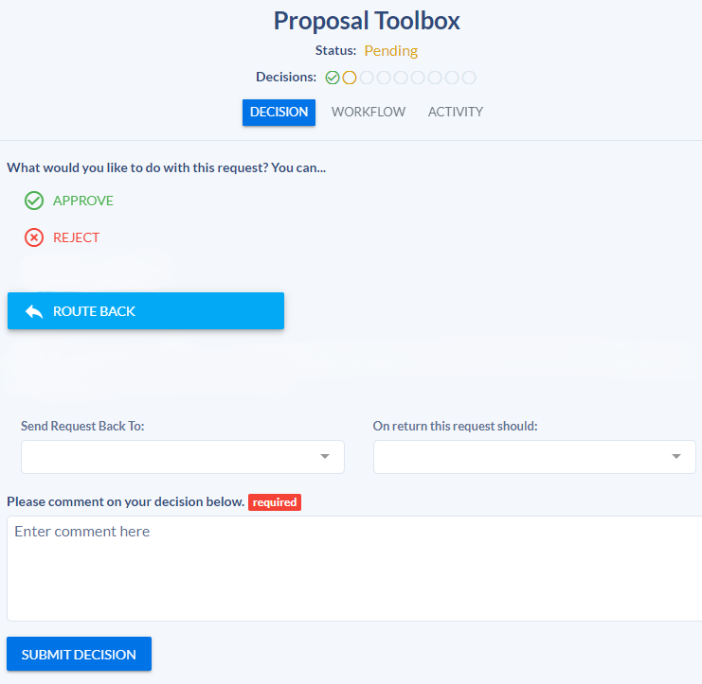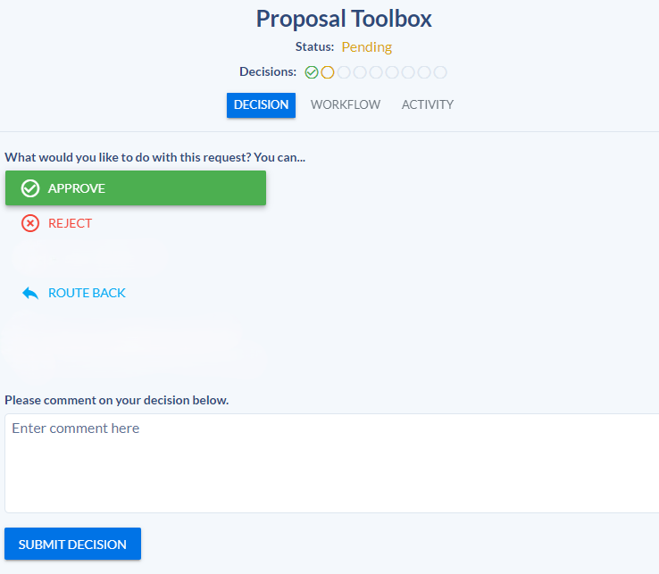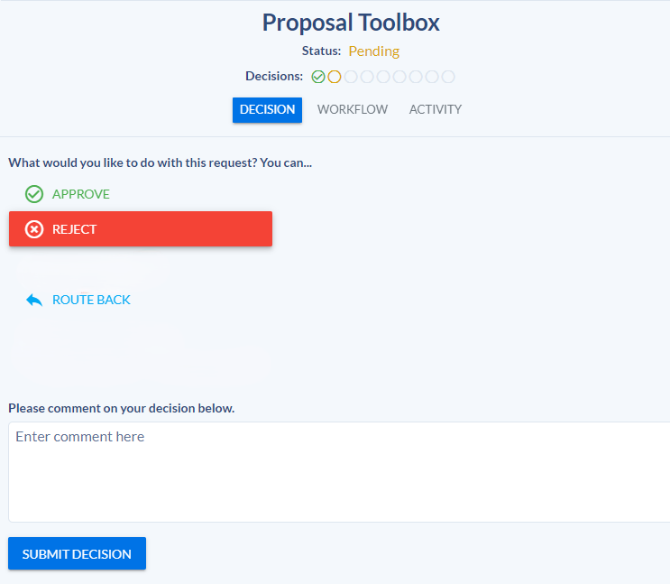Below are the three options you will have when making a decision for a proposal in your workflow step.

**Route Back**

If there are issues that need to be addressed before a proposal can move forward, route it back using the ‘Route Back’ option. Once you’ve selected ‘Route Back,’ you will need to select who you would like to send it back to and what they need to in order to get the proposal approved. It is also required that you leave a comment on this step.

**Reject**

This option is not recommended, but can be used to send a proposal all the way back to the author. If you are rejecting a proposal, please include a comment that details why that decision has been made.

**Approve**

If you have viewed the proposal and you have no issues with the changes/new course or program being proposed, select ‘Approve’ and then ‘Submit Decision.’ This will send the proposal to the next step in the workflow. You can also leave a comment if necessary.