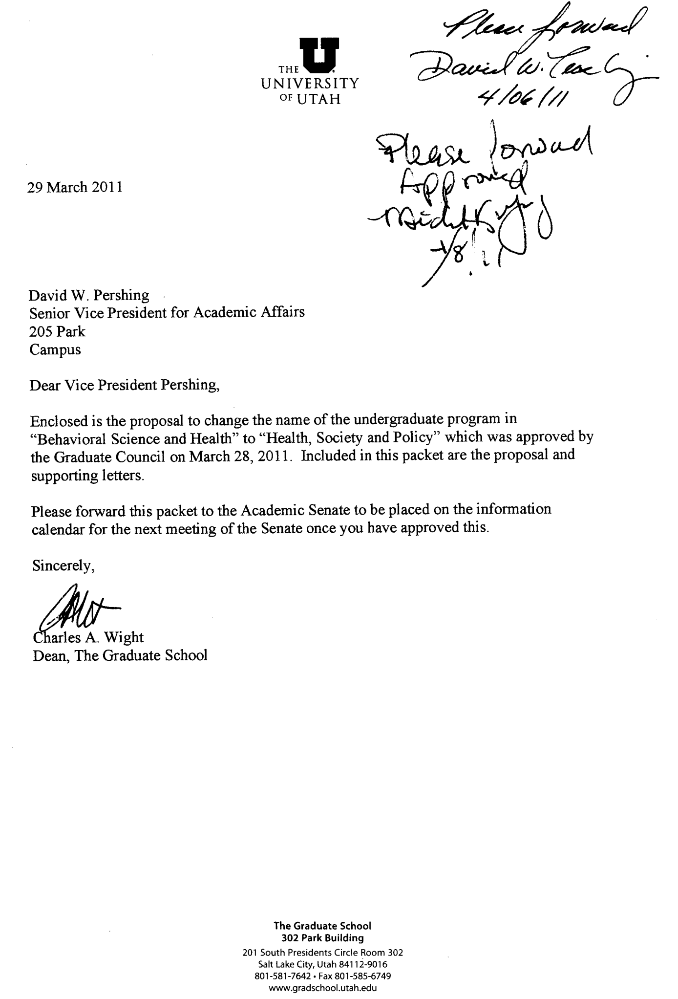
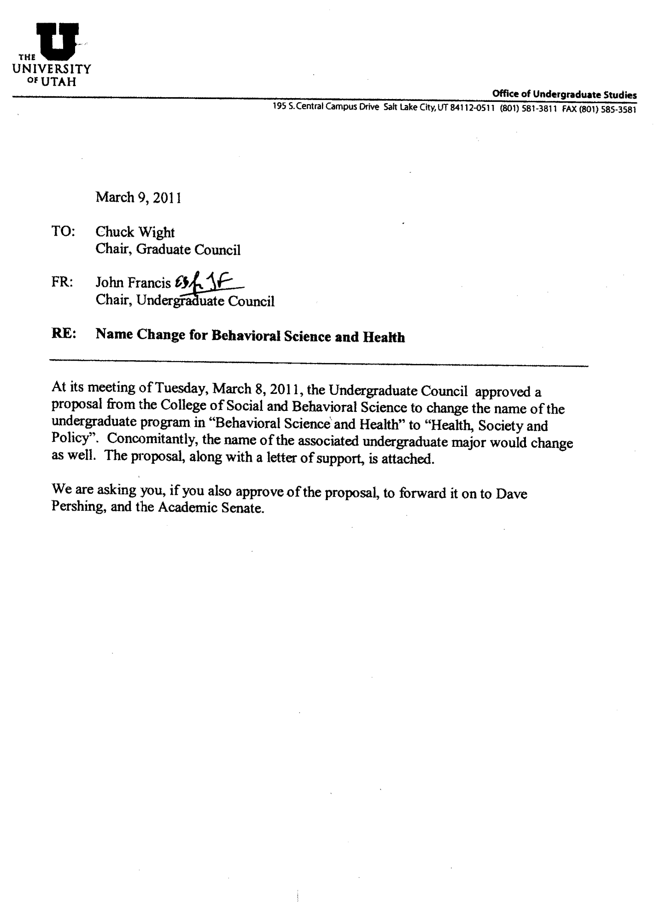

Name Change of Undergraduate Major Program and Degree
From: Polly Wiessner, PhD and Norman Waitzman, PhD,
Co-Directors, Behavioral Science and Health (BSH)

1. Request
Change the name of the undergraduate program, Behavioral Science and Health (BSH), administratively lodged within the College of Social and Behavioral Science, to Health, Society and Policy (HSP)

2. Need:
Behavioral Science and Health (BSH) is a vital undergraduate major whose full mission is improperly conveyed by its name, particularly as interpreted by students. This is the assessment from several important constituencies that weighed in with co-Directors Polly Wiessner (Professor, Anthropology) and Norman Waitzman (Professor, Economics) in dedicated discussions about the program during the 2009-2010 academic year when the program was under external review, and when enrollments in the program had begun to decline.

The most important of these constituencies were college advisors lodged with the responsibility of conveying to students the nature and suitability of the major. Nearly universally, the advisors for medical school aspirants, and for the broader advising community in the University, indicated that the use of “Behavioral Science” too often suggested to students that the major was anchored in psychology rather than in the broader health and policy disciplines that provide a good basis for preparing students to go on into careers in medicine and allied professions; in public health; and in health care policy and administration. The external reviewers were also unanimous in supporting a new title. Of the new titles of the major discussed, “Health, Society and Policy” was the one that was most enthusiastically received. It has won endorsement in a canvas of the major’s advisory board. It conveys the multifaceted dimensions associated with health, and with health policy, in a cogent and appealing manner. We therefore propose the change in title from Behavioral Science and Health (BSH) to Health, Society and Policy (HSP) to better conform to what the major actually accomplishes with respect to undergraduate education, and to better convey to students the content of the major.

3. Institutional Impact - Will the proposed recommendation affect enrollments in instructional programs of affiliated departments or programs? How will the proposed recommendations affect existing administrative structures? What (new) faculty, physical facilities or equipment will be impacted?

The institutional impact will be minimal. The direct enrollment can be expected to revert back to 20 or so additional majors per year, which can be accommodated by existing administrative and
capital structures, and by allied classes.

4. Costs - What costs are anticipated? Describe any budgetary impact, including cost savings, on other programs or units within the institution.

Costs will be minimal, perhaps a one-time fixed cost of $300-$500 to change the website, brochures, and class schedules listing the name and new prefix. The Program currently has the funds to undertake these changes.

5. Practice Elsewhere - Cite trends in the discipline. Provide a summary or compilation of names used in peer institutions.

This is a relatively unique undergraduate program, with relatively few peer programs in the country. Indeed, this was one of the observations of the external reviewers of the program. Based on a casual Google search, Behavioral Science and Health is relatively rare as an undergraduate program, whereas there are several prominent “health and society” and “health policy” programs in the country, particularly at the graduate level, and even at the postdoctoral level. There is a
Center for Society and Health at Harvard (http://www.hsph.harvard.edu/society/). Robert Wood
Johnson Foundation sponsors a prestigious “Health and Society” post-doctoral scholar program (http://www.healthandsocietyscholars.org/). On the other hand, it appears that one undergraduate program at U of Rochester is changing its name for Health and Society to Health, Behavior and Society (http://www.rochester.edu/college/ccas/healthandsociety/).

6. Changes, if any, in precise names of degrees offered.
The BA/BS degree conferred by the College of Social and Behavioral Science would now list the major as Health, Society and Policy (HSP).

