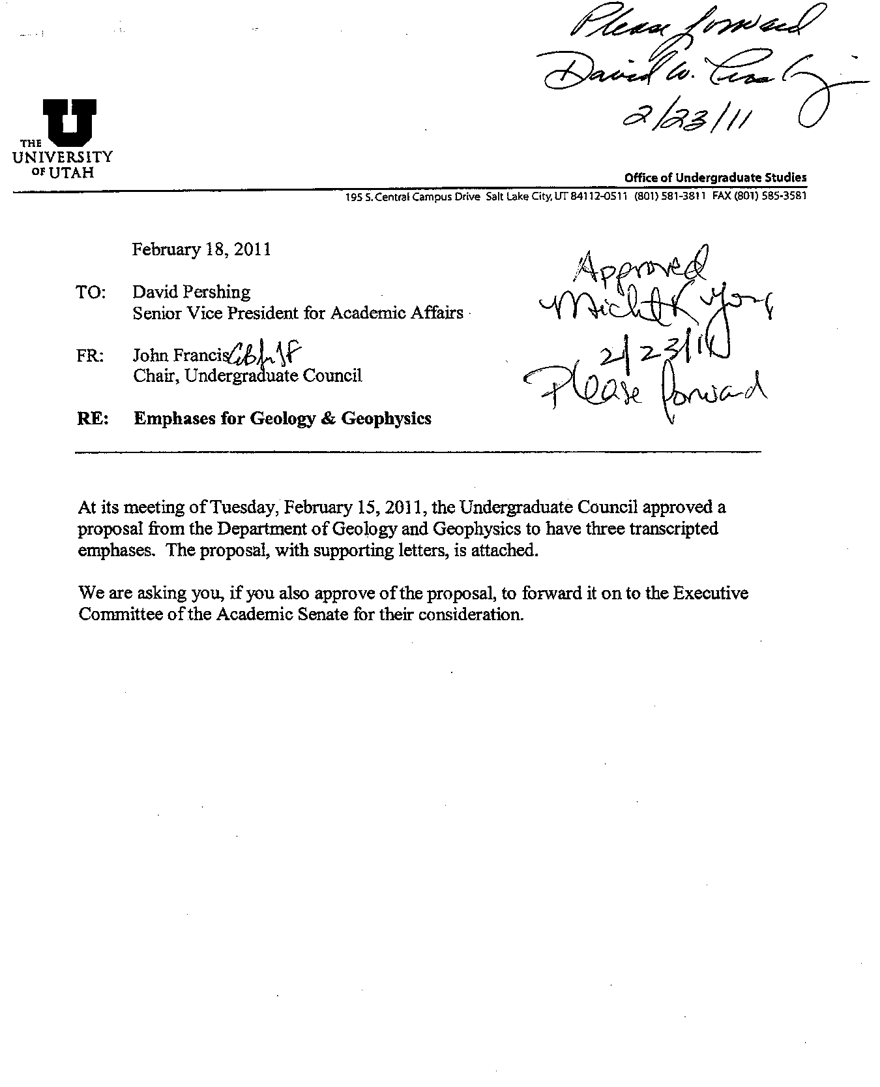

Request

Emphases Designations

In Undergraduate

Geoscience

Degree

Department of Geology & Geophysics
College of Mines and Earth Sciences
115 S. 1460 E. Rm 383
Salt Lake City, UT 84112

January 30, 2011

Section I: Action

The Department of Geology and Geophysics (GEO) at the University of Utah proposes that the following emphasis areas be entered on the BS Geoscience Degree, Geology & Geophysics transcripts:

* Geology
* Environmental Geoscience
* Geophysics

This will allow the Emphasis Areas be listed on transcripts, DARS and Declared Majors Status.

All students electing the Geoscience Major are required to complete a common set of core courses that constitute 28 credit hours of the 81 credit hours in the major. The balance of the credit hours (53) accrues in courses from one of three emphasis areas. Each emphasis area add 12 additional required credit hours, 12 credit hours of degree-program electives and 29 credit hours of allied courses in Mathematics, Chemistry, and Physics. The balance of the courses to meet the University of Utah required minimum of 122 credit hours for any undergraduate degree are accrued through university-required courses and electives.

CORE Courses (28 Credit hours, Required for all Geoscience majors)
Course Number | Course Title | Hrs. | Prerequisites
GEO 1110 | Introduction to Earth Systems | 3 | Must register for GEO 1115
GEO 1115 | Introduction to Earth Systems Lab | 1
GEO 3080 | Earth Materials I | 4 | CHEM 1210
GEO 3090 | Earth Materials II | 3 | GEO 1110, GEO 3080, MATH 1210
GEO 3060 | Structural Geology and Tectonics | 3
GEO 3010 | Geophysics | 3 | MATH 1220, Co-GEO 3080
GEO 5760 | Stratigraphy and Sedimentary Processes | 4 | GEO 3090
GEO 4500 | Field Methods | 3 | GEO 3060; Upper Division CW
GEO 4510 | Field Geology | 4 | GEO 4500

Completion of the requirements in an emphasis area is an integral part of the Geoscience degree. Requirements for each emphasis area are given below. Each emphasis area consists of a body of courses that total 53 credit hours. Electives: Any upper division course in the Colleges of Mines and Earth Sciences, Science, or Engineering, or other upper division course by approval. (Approved electives in College of Social Behavioral Sciences: GEOG 3110, 3140, 3200 (GEOG 1000 or instructor's consent), 3350 (GEOG 1000 or instructor's consent), 5100 (GEOG 1000 and MATH 1030 or MATH 1050 (or equivalent) or instructor's consent), 5150 (GEOG 5140/6140), 5160 (GEOG 5140/6140); URBPL 5360; ANTHR 4261; ECON 5250 (ECON 4010 or all of the following: ECON 2010, 2020, 3250, and knowledge of college algebra); POL_S 5322.)

Section II: Need

Listing Emphasis Areas on transcripts would bring recognition to the area of study. When students apply for employment or to graduate school, having the specific emphasis designation on the transcript would make it easier to determine the professional area in which the candidate has expertise and professional preparation.

The Geology Emphasis provides the greatest flexibility for the student. Students may explore the diversity of the field or focus more tightly to gain greater depth of understanding.

The Environmental Emphasis focuses on connections and interactions with the biosphere, hydrosphere and atmosphere providing the student with a strong background to contribute to addressing environmental issues in society. Courses in Biology, Hydrology and Atmospheric sciences contribute to its interdisciplinary nature.

The Geophysics Emphasis is for students that desire to the study Earth’s interior using a highly quantitative approach. This body of knowledge is applied to the study of geological hazards (e.g., earthquakes) and resource exploration (metals and energy resources).

The Geoscience Degree was the result of merging three separate degrees into one degree with three emphasis areas. This degree was simpler to market and allows more room for electives making it easier for transfer students to enter the program and for students to pursue dual majors. We believe that it has also resulted in the desired increase of majors.

Section III: Institutional Impact

This proposal will have no institutional impact.

Section IV: Finances

There will be no financial impact to the Department of Geology & Geophysics or the College of Mines and Earth Sciences. The emphases areas have been in place since 2005. This proposal only seeks that the Emphasis Areas be listed on transcripts, DARS and Declared Majors Status.

Geoscience Emphases

Geology Emphasis (53 credit hours)

Additional required courses |  | 12 | Prerequisites
GEO 1220 | Earth History | 3 | GEO 1110, 1115
GEO = 9 credits, upper division |  | 9
Degree program electives |  | 12
12 Credit hours |  | 12
Allied Science Requirements |  | 29
CHEM 1210 | Chemistry I | 4
CHEM 1215 | Chemistry I Lab | 1 | Co-CHEM 1210
CHEM 1220 | Chemistry II | 4 | CHEM 1210
CHEM 1225 | Chemistry II Lab | 1 | Co-CHEM 1220
MATH 1210 | Calculus I | 4 | "C" or better in MATH 1050 AND MATH 1060 OR Math ACT score of at least 28 OR Math SAT score of at least 630 OR AP Calculus AB score of at least 3
MATH 1220 | Calculus II | 4 | "C" or better in MATH 1210 OR MATH 1250 OR MATH 1270 OR AP Calculus AB score of at least 4 OR AP Calculus BC score of at least 3
METEN 3070 - OR | Statistics | 3
MATH 3070 | Statistics I (4) |  | "C" or better in MATH 1220 OR MATH 1250 OR MATH 1270 OR AP Calculus BC score of at least 4
PHYS 2210 | Physics for Sci/Eng. I | 4 | MATH 1210
PHYS 2220 | Physics for Sci/Eng. II | 4 | MATH 1220, PHYS 2210

Environmental Geoscience Emphasis (53 credit hours)
Additional required courses |  | 12 | Prerequisite
12 credits among following 3 areas:
Minimum of 3 credits in each area
1. Biosphere |  | 3 | (see footnote)
2. Hydrosphere |  | 3 | (see footnote)
3. Atmosphere |  | 3 | (see footnote)
3 additional credits from 1, 2, or 3 |  | 3
Degree program electives |  | 12
12 Credit hours |  | 12
Allied Science Requirements |  | 29
CHEM 1210 | Chemistry I | 4
CHEM 1215 | Chemistry I Lab | 1 | Co-CHEM 1210
CHEM 1220 | Chemistry II | 4 | CHEM 1210
CHEM 1225 | Chemistry II Lab | 1 | Co-CHEM 1220
MATH 1210 | Calculus I | 4 | "C" or better in MATH 1050 AND MATH 1060 OR Math ACT score of at least 28 OR Math SAT score of at least 630 OR AP Calculus AB score of at least 3
MATH 1220 | Calculus II | 4 | "C" or better in MATH 1210 OR MATH 1250 OR MATH 1270 OR AP Calculus AB score of at least 4 OR AP Calculus BC score of at least 3
METEN 3070 - OR | Statistics | 3
MATH 3070 | Statistics I (4) |  | "C" or better in MATH 1220 OR MATH 1250 OR MATH 1270 OR AP Calculus BC score of at least 4
PHYS 2210 | Physics for Sci/Eng. I | 4 | MATH 1210
PHYC 2220 | Physics for Sci/Eng. II | 4 | MATH 1220, PHYS 2210

1. Biosphere: Choose from courses such as GEO 3180 (pre-req. GEO 1110); BIOL 1210, 1330, 1400, 2010, 2020 (pre-req. BIOL 1210 (or equivalent) and BIOL 2010, and CHEM 1210), or 3410.

2. Hydrosphere: Choose from courses such as GEO 3300, 3800 (pre-req. GEO 1110), 5370 (pre-req. CHEM 1210, 1220 or consent), 5350 (pre-req. MATH 1220), and 5390 (pre-req. GEO 3080, 3090, 3400, 5350, 5360, 5370, Co- 5385, 5500).

3. Atmosphere: Choose from courses such as ATMOS 3000, 3100 (pre-req. CHEM 1210, MATH 1220, and PHYS 2210, or Instructor's consent), 5400, and GEOG 3210.

Geophysics Emphasis (53 credit hours)
Additional required courses |  | 12
9 credits among following 3 areas:
One course in each area:
Seismology |  | 3 | (see footnote)
Physical Fields |  | 3 | (see footnote)
Other |  | 3 | (see footnote)
MATH 5600 or GEO 5560 |  | 3
Degree program electives |  | 12
12 Credit hours |  | 12
Allied Science Requirements |  | 29
CHEM 1210 | Chemistry I | 4
MATH 1210 | Calculus I | 4 | "C" or better in MATH 1050 AND MATH 1060 OR Math ACT score of at least 28 OR Math SAT score of at least 630 OR AP Calculus AB score of at least 3
MATH 1220 | Calculus II | 4 | "C" or better in MATH 1210 OR MATH 1250 OR MATH 1270 OR AP Calculus AB score of at least 4 OR AP Calculus BC score of at least 3
MATH 2210 | Calculus III | 3 | "C" or better in MATH 1220 OR MATH 1250 OR MATH 1270 OR AP Calculus BC score of at least 4
MATH 2250 | ODEs & Lin. Alg. | 3 | "C" or better in MATH 2210 OR MATH 1260 OR MATH 1280 OR (MATH 1220 AND PHYS 2210 OR PHYS 3210)
METEN 3070 – OR | Statistics | 3
MATH 3070 | Statistics I (4) |  | "C" or better in MATH 1220 OR MATH 1250 OR MATH 1270 OR AP Calculus BC score of at least 4
PHYS 2210 | Physics for Sci/Eng I | 4 | MATH 1210
PHYS 2220 | Physics for Sci/Eng II | 4 | MATH 1220, PHYS 2210
Geophysics: One course from GEO 5211, 5250, 5260, 5310, and 5320

